Glucose Tolerance Test (GTT) Guide – Lab Assistant

Table of Contents
GTT Checklist 2
1-Hour GTT 5
3-Hour GTT 6
Pre-Charting 6
3-Hour GTT Documentation 7
2-Hour Non-Gestational GTT 9
Draw Order and Collecting Blood Glucose Samples 10
3-hour GTT: 10
2-hour GTT: 11
Fasting Glucose > 126 (diagnostic for GDM) 12
MA/LPN/RN Documentation Related To Fasting Glucose > 126 (Diagnostic of GDM) 13
Management of Nausea &/or Vomiting During GTT 14
Nausea & Vomiting Documentation for MA/LPN/RN 14
Completing the Encounter – MA/LPN/RN 16

GTT Checklist
1 Hour Glucose
- Orders
  - Verify orders have been placed
  - Update appointment notes to indicate GTT start time
- Release orders from Order Review activity if needed.
- Print lab label
- Draw patient
! Important: This is a screening test. Your patient will need to finish drinking the Glucola within 5 minutes. If they exceed 5 minutes, the test needs to be terminated. Patient may repeat Glucola test no earlier than 24 hours. Best practice is to draw the patient ON TIME. You have up to a 10-minute window after draw time.
- Click the link if your patient is experiencing nausea or vomiting
- Send specimen to central lab

3 Hour Glucose
- Pre Charting:
  - Select appropriate patient on your schedule and open Pre Charting Activity
  - Ensure lab order are placed
  - Create new progress note and enter
    - .WHA3HRGTTLABASSISTANT.
    - Fill in appropriate information
  - Add visit diagnosis: Elevated 1 hour glucose tolerance test
- When the patient arrives:
- Print orchard labels
  - Ask the patient:
    - How long they’ve been fasting
    - Do you have a current diagnosis of Diabetes?
- Perform first blood draw click the link for draw order
- Run POC
  - Fasting value must be under 126 to proceed with testing
  - Click the link if value is over 126
- Provide 100mg glucola to patient
! Important: Your patient needs to drink the Glucola in front of you and will need to finish the Glucola within 5 minutes. Take note of the time they began their drink.
- Escort patient to designated exam room
  - Click the link if patient is experiencing nausea or vomiting
- Documentation:
- Enter Chief complaint
  - Abnormal Glucose
- Progress Note:
  - F2 through and complete smartphrase:
    - Elevated 1Hr GTT documented
    - Patient with current diagnosis of diabetes
    - Order in place for 3 Hr GTT
    - Fasting
    - POC glucose value
- Select WHA Proceed/Don’t proceed with GTT variable
  - select the appropriate option to continue with documentation
! Important: The encounter and note need to remain unsigned until all four draws have been completed or if there were complications during the appointment and the patient or an RN discontinue the test.
- Complete documentation:
  - This Visit
    - Add elevated glucose tolerance test if not previously done
  - Level of Service
    - RN NC CHK
    - Sign encounter
- Send specimen to central lab

2 Hour Glucose
- Check for orders.
- Print Orchard labels.
- Draw patient’s fasting :
  - Click the link for draw order
! Important: DO NOT run the fasting blood draw as a POC test.
- Provide 75g of glucola to patient.
- Draw patient 2 hours after drinking glucola.
- Send specimen to central lab.
- If patient experiences an adverse reaction:
  - Create Documentation Only Encounter and document in the progress note:
    - The adverse reaction
    - Who you may have reached out to
    - What care the patient received.

1-Hour GTT
When you have a patient on your schedule for a 1-hour GTT, you want to verify whether orders have been previously placed, and update the appointment notes accordingly.
- Go to your Lab Schedule and single click on a patient.
- Click on the Show Orders button to open the Order Review.
- Verify the order was placed by a WHA provider using the default order report.
- Return to your Lab schedule to add an appointment note of 28 wk. labs.
  - To indicate labs are time sensitive, add GTT start Time to prompt patient services team, at time of check-in, to ask and document when the patient started her Glucola drink.
! Important: This is a screening test. Best practice is to draw the patient ON TIME. You have up to a 10-minute window after draw time.

- Click Notes button and remove See Orders.
- Type; GTT Start Time, ABC, RPR, then Accept the Note.
  - When patient arrives and is ready to be drawn, you can release the orders if they are in a Standing Status using the following steps.
- Single click on patient from your Lab Schedule.
- Click the Show Orders button
- From the Order Review – Open Orders activity, single click on the first standing order.
- Hold the Shift key on your keyboard and click on the last standing order to highlight all three orders.
- Click Release, print their Orchard Labels then click the X next to their name to close the patient’s chart.
- If your patient is experiencing nausea/vomiting during the first hour, click the link for Management of Nausea/Vomiting.

Return to GTT Checklist

3-Hour GTT
When you have a patient on your schedule for a 3-hour GTT, there are a few things you may want to do to prepare. Let's start with some preliminary charting to prepare for the patient's upcoming lab appointment, verify that all orders are placed, update appointment notes if additional labs are required, and ensure you have sufficient time to spend with the patient.

Pre-Charting
- From the Lab Schedule, notice that your patient is in a Scheduled Status.
- Double click on the patient’s appointment to open the Pre-Charting activity.
  - Note: You have limited sections available for documentation, including Visit Diagnosis, Problem List, Medications, Orders, Patient Instructions, and Notes.
- Click on Chart Review and select the Lab tab to ensure orders for a 3-Hour GTT are placed.
  - Be sure to update your appointment notes if you notice additional labs are being drawn.
  - If these lab orders are not present, you will need to reach out to the appropriate support staff member to enter those order(s).
- Go to the Progress Notes Activity.
- Enter the following smartphrase into the blank space of the note: .WHA3HRGTTLABASSISTANT.
  - Notice the variables in the smartphrase that assist with visit-specific documentation.
- Use F2 or single click on the variables to fill in as much information as possible.
  - Use Chart Review and search tools to find the necessary historical information.
- Go to Visit Diagnosis, click on the Problems dropdown and select Elevated Glucose Tolerance Test.
- Once you have completed Pre-charting, click the X next to the patient’s name to exit pr-charting. Return to GTT Checklist

3-Hour GTT Documentation
Once the patient has arrived for their lab appointment, you will bring them to the draw station and proceed with the following tasks.

- Print out Orchard labels.
- Once patient has verified and initialed their Orchard labels, ask the following questions and record their response:
  - How long have you been fasting for? (patients can be fasting 8 – 12 hours, no more than 24).
  - Are you currently diagnosed with diabetes?
- Perform the first blood draw. Click the link for 3 hr. Draw Order & Collecting Blood Samples.
- Using the glucometer, run a POC test to ensure that her fasting glucose is less than 126.
  - Note: If your patient’s fasting level is over 126, click the link for Fasting Glucose > 126 next steps.
- Once you have verified that their levels are within the normal range, administer 100 mg of Glucola to the patient.
! Important: Your patient needs to drink the Glucola in front of you and will need to finish the Glucola within 5 minutes. Take note of the time they began their drink.
- Walk your patient back to the designated area (exam room) where the remainder of the test will take place.
- Instruct the patient to reach out to you if they experience any nausea/ vomiting.
  - Note: Experiencing vomiting within the first hour of the test will result in discontinuing the test. Click here for Management of Nausea/Vomiting and follow step 4 of that section.
- Return to your workstation.
- Update the appointment notes on the schedule to include the room number and the start time.
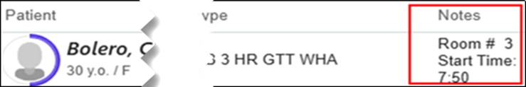
- From your Lab Schedule, double-click on your patient to open the encounter.
- Click Chief Complaint to open the section.
- In the Add a new reason search field, type; Abnormal Glucose, press Enter and Close the section.
- Go to the Progress Note.
- Add the following smartphrase .WHA3HRGTTLABASSISTANT in your blank note.
  - Skip this step if you have already completed pre-charting for this patient.
- Use F2 or click the variables to work through the checklist to ensure it is filled out appropriately.
  - Elevated 1Hr GTT documented:
  - Patient with current diagnosis of diabetes:
  - Order in place for 3 Hr GTT:
  - Fasting:
  - POC glucose value:
- Click the WHA Proceed/Don’t proceed with GTT variable, select the appropriate options to continue with documentation.
- Document the time the patient began their drink.
- Once you have completed all 4 draws, finish your documentation.
! Important: The encounter and note need to remain unsigned until all four draws have been completed or if there were complications during the appointment and the patient or an RN discontinue the test.
- Go to This Visit activity.
- Under the Visit Diagnosis section, click on the Problems button to reveal a list and select Elevated Glucose Tolerance Test.
- Level of Service, select RN NC chk (PR Nurse Visit No Charge), enter the Authorizing Provider, which would be the provider on the 3hr GTT order.
- Click Sign the Encounter.

2-Hour Non-Gestational GTT
A 2-hour glucose tolerance test (GTT) may be performed for various reasons. At WHA, the most common indications include postpartum evaluation for patients with a history of gestational diabetes, as well as screening for glucose intolerance in patients without a history of gestational diabetes.
Patients diagnosed with Gestational Diabetes are strongly advised to return for a follow-up appointment between 8 and 12 weeks postpartum to confirm that their blood glucose levels have normalized. Prior to the test, patients will receive detailed instructions from Patient Services. (click here to read through the instructions).
- The patient's provider or clinical staff should send a staff message to their designated Patient Services Pool, indicating that the patient requires a 2-Hour Glucose Tolerance Test and specifying the preferred completion date and time.
  - Click here to view the Patient Services 2 Hour GTT Workflow.
- Patients will be advised to fast 8-12 hours prior to their 2-hour GTT.

When the patient arrives for their lab appointment, follow the steps below.
- Print out Orchard labels.
- Patients should verify and initial their Orchard labels.
- Draw the patient for their fasting level using the Grey Top tube. Click the link for 2 hr. Draw Order & Collecting Blood Samples.
! Important: DO NOT run the fasting blood draw as a POC test.
- Give the patient their 75 g of Glucola to drink and set a timer for 2 hours.
- For patients who experience nausea and vomiting within the first hour, click link here.
- After the 2 hours are up, draw the patient's final blood sample using a Grey Top tube.
- Make sure to send 2 Grey Top tubes to the Central Lab—one for the fasting level and one for the 2-hour level.
- If your patient experiences an adverse reaction to the Glucola, you will record this information in a Documentation Only encounter. Click here to view 'Adverse Reaction Workflow'
- In your note template, document the adverse reaction, who you may have reached out to and what care the patient received.
Return to GTT checklist

Draw Order and Collecting Blood Glucose Samples

3-hour GTT:
- Process Order in Orchard -- Will Print out all 6 labels at time of processing the order with the time of processing -- **Printed out times on the label will need to be manually changed to reflect the time of actual draw**
  - Master Label – Affix to Daily draw sheet
  - Point of Care Label – Lavender Tube
  - Fasting – 00 – Grey top Tube
  - 1hr – 01 – Grey top Tube
  - 2hr – 02 – Grey top tube
  - 3hr – 03 – Grey Top Tube
- Grab your Lavender & one Grey top tube.
- Draw Lavender tube FIRST (only need to fill approx. ½ way) THEN Grey top tube (fill). Invert both specimens gently 8-10 times.
- Label Lavender tube with “Point Of Care/Extra” label & Grey Top Tube with “Fasting-00” orchard label.
- Point of Care Testing from Lavender Tube -
  - Use Smear Safe device to pierce the cap of the lavender tube to obtain the POC fasting value – refer to Standard Operating procedure for Accu-Chek use.
  - Once the value is obtained, discard lavender tube in sharps container. – If patient has questions about discarding sample – There is an additive in the tube, so need to get enough blood in the tube to avoid compromising the sample.
- Reserve Grey Top Tube to be sent to lab after final lab draw is obtained.
- Once you know their fasting glucose, enter the value into the checklist and press F2 to continue to the next field.
- If patient’s fasting glucose was less than 126, then will give the patient the Glucola to drink and document the start and stop time. Patient needs to finish within 5 minutes.
  - Affix patient label to a 3hr timer – set 1hr, 2hr & 3hr draw times to reflect due times from time patient starts glucola.
  - If applicable at your site, provide your patients with the written draw times for their awareness.
  - The note may then be pending until either all four draws have been completed, or the patient experiences vomiting or requests to terminate testing.
    - In such cases, the appropriate action would be taken, and a clinical staff member will assume responsibility for documentation and completion.
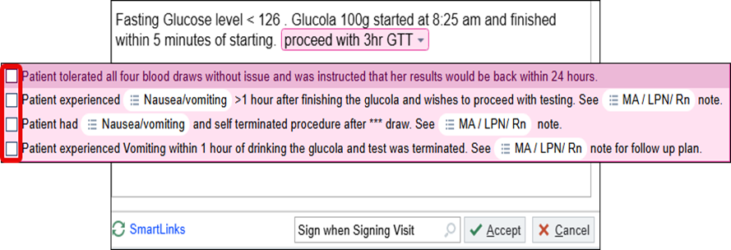
  - If no further clinical staff involvement is required, proceed with steps 16–22 outlined in the 3-hour GTT documentation section to complete your charting within Epic.

2-hour GTT:
- Process Order in Orchard -- Will Print out all 3 labels at time of processing the order with the time of processing -- **Printed out times on the label will need to be manually changed to reflect the time of actual draw**
  - Master Label – Affix to Daily draw sheet
  - Fasting – 00 – Grey top Tube
  - 2hr – 02 – Grey top tube
- Label Grey Top Tube with “Fasting-00” orchard label.
- Give the patient the Glucola to drink and document the start and stop time. Patient needs to finish within 5 minutes.
- Affix patient label to a 2-hr timer – set draw time to reflect the time due from when the patient starts their Glucola drink.
- If applicable at your site, provide your patients with the written draw times for their awareness.
Note: If the patient experiences any adverse reactions such as nausea/vomiting or wants to terminate testing for any reason, a clinical staff member would be notified, then take over and complete any necessary documentation.

Fasting Glucose > 126 (diagnostic for GDM)
- If the patient's fasting glucose level exceeds 126, the Glucola will not be given. Additionally, if the patient does not have a same-day appointment with their clinician and a clinical staff member is unable to connect with them in clinic directly, the patient will be informed that a clinical staff member or nurse will follow up via phone to discuss subsequent steps.
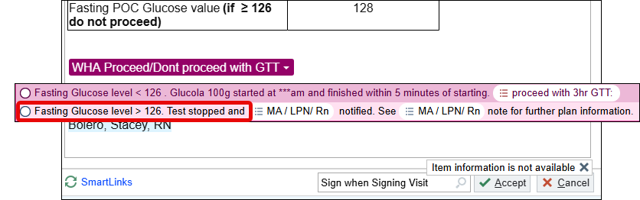
- Give awareness to clinical teams that a note will be routed to them for follow-up. Ensure all required fields are completed if you have initiated a Progress Note for a patient scheduled for a 3-hour GTT lab appointment before signing. If your patient was here for either a 1- or 2-hour GTT, don’t forget to document this in your note you send to the clinical team.
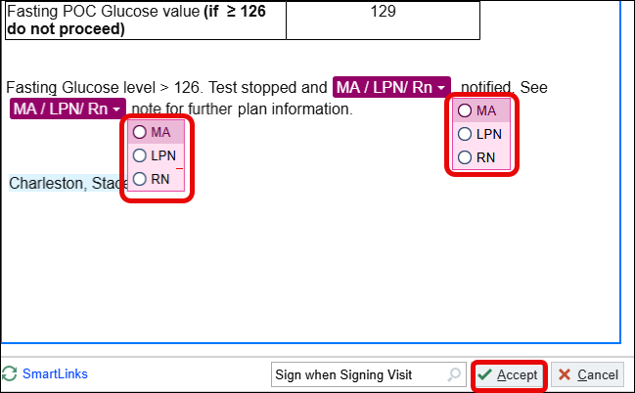

MA/LPN/RN Documentation Related To Fasting Glucose > 126 (Diagnostic of GDM)

- Start a new progress note by clicking Create Note in the Progress Notes section.
- Type .WHA3HRGTTELEVATEDFASTING into the blank note
- Use F2 to satisfy the variables and complete your documentation.
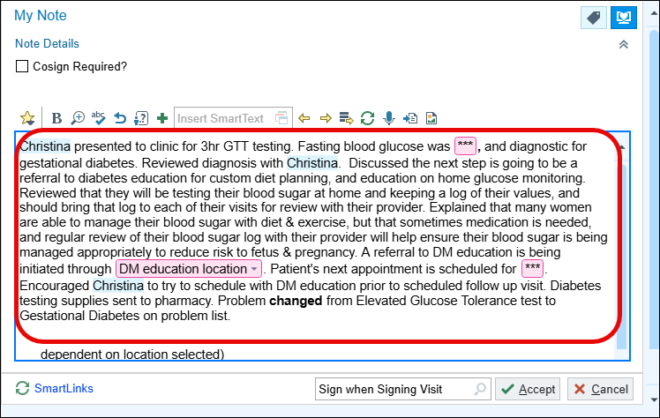
- Go to This Visit tab and scroll to the Problems List.
- The MA/LPN/RN should change the problem from Elevated Glucose Tolerance Test to Gestational Diabetes.
- Click the triangle next to the problem and search for gestational diabetes.
- Specify whether the condition is managed though Diet, Insulin, or Oral Medication. In most cases, this will start with diet control.
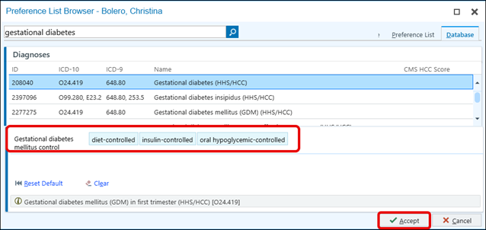
- Click Accept to confirm the change
- Click Accept again to save the change.
- MA/LPN/RN will explain GDM Dx, send diabetic supplies, complete order for Diabate’s education and provide contact information to Diabetes Edu to the patient.
- Send documentation to patients’ provider as an FYI.
- The patient will need a follow up appointment with a clinician in 1 week.

Management of Nausea &/or Vomiting During GTT

*Goal is for the Lab Assistant to help patient complete test*

If patient experiences emesis prior to 1hr draw- test will need to be terminated. Patients are given the option to repeat test with Zofran ahead of time.
- If desired to try again with pre-medication send message to Advice Pool to send Rx. Send patient to front desk to reschedule at least 24 hours in the future, but as soon as possible.
- Patient declines to repeat test – Send message to Advice Pool for alternative recommendations & follow up.

It is acceptable to proceed with a 1, 2, or 3 hour glucose tolerance test if a patient ONLY experiences nausea or vomits after the 1 hour blood draw (or after the 1 hour time period for 2 hour GTTs). If a patient does vomit within the 1 hour time frame for any GTT, the test will need to be terminated and rescheduled for another day.

- Lab Assistances should try the following interventions prior to reaching out to clinical services team member:
  - Lying down in exam room
  - Cool cloth
- If above intervention is unsuccessful, a Clinical Staff Member (MA/LPN/RN) should consult with a provider for a Zofran order first. Ensure that the order is approved by a provider verbally or via secure chat and the order is in place before administering it to the patient.
  - Zofran 4mg dissolvable tablet if desired & no allergies/contraindication.
  - Clinical staff to take over and complete documentation regarding Zofran administration.
- Lab to complete their Progress Note and continue drawing until otherwise informed.
- If patient is unable to complete all 4 draws or desires to terminate testing due to feeling poorly, follow the workflow for notifying a provider, or clinical team member (MA/LPN/RN).

Nausea & Vomiting Documentation for MA/LPN/RN

- Start a new progress note by clicking Create Note in the Progress Notes section.
- Type .WHA3HRGTTNAUSEA into the blank note
- This smartphrase offers standardized options for documenting interventions related to the management of nausea and vomiting, as well as details regarding the patient's completion or termination of the test.
- If you are overseeing a patient's management for nausea or vomiting, ensure that their vital signs (blood pressure, heart rate, respiratory rate) are obtained as baseline measurements before discharge home.
- Continue to monitor these vitals as needed during testing if symptoms worsen and any abnormal findings should be reviewed with the clinician.
  - These can be documented in the rooming activity; and clicking New Set of Vitals with each evaluation.
  - If you administer Zofran, ensure it is ordered through the Preference List as a Clinic-Administered Medication.
  - Document the administration in the MAR, including the lot and NDC numbers; therefore, you may want to keep the medication packaging for reference.
  - Associate a diagnosis code, click the two gray rings below the medication OR Dx Association.
  - In the search field, type; Nausea and vomiting in pregnancy and press Enter.
  - To sign the order, change the Frequency to Once, then click Accept and Sign Orders.
  - Click the MAR activity to go to the Medication Administration Record.
  - Find Zofran and click New Administration.
  - Enter the NDC #, the Lot #, and the Billing Provider (if blank), then click Accept.

Completing the Encounter – MA/LPN/RN

- Complete remainder of smartphrase within documentation field.
- The final component needed to close/sign the encounter is the Level of Service located on the task bar.
- Click RN NC chk (PR Nurse Visit No Charge) and then enter the Authorizing Provider, which would be the provider on the 3hr GTT order.
- Clicking Sign Encounter once documentation is completed.

